In order to study the interaction of the bacterium Neisseria gonorrhoeae (Ngo) with human cells, researchers have developed a transgenic mouse model. These mice bear the human gene CEA (CEA transgenic mice or CEAtg).

- As a first experiment, scientists have infected Wild Type (WT) mice (not the transgenic ones) with Ngo cells bearing different types of a cell surface protein called Opa (either no Opa (Opa-) or Opa known to interact with different molecules. (For instantce Opa_{CEA} is know to interact with the human CEA receptor). Below is a picture of genital epithelia of female wt mice either uninfected or infected with Ngo. Describe what type of data those are and how you interpret the impact for Ngo infection on WT mice genital epithelia. (4 points)
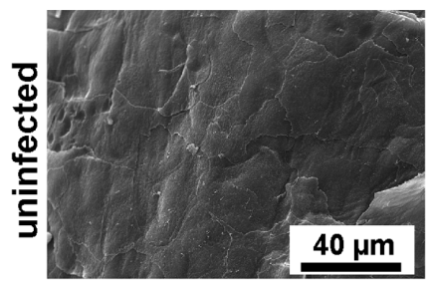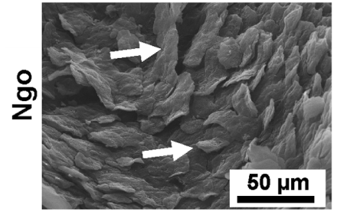

- The graph below characterizes the number of living bacteria that could be recovered from the urogenital region of mice infected with 10⁸ bacteria a day before. Summarize briefly the results of the graph and draw a conclusion on the interaction between the human CEA gene and the bacterial membrane protein Opa. (Opa_{HSPG} is binding to heparan sulfate, Opa_{CEA-B} to CEA) (5 points).
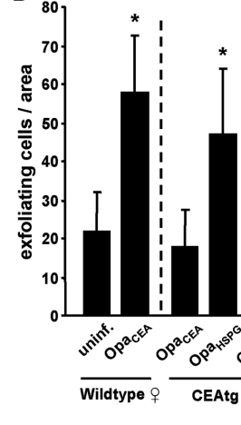
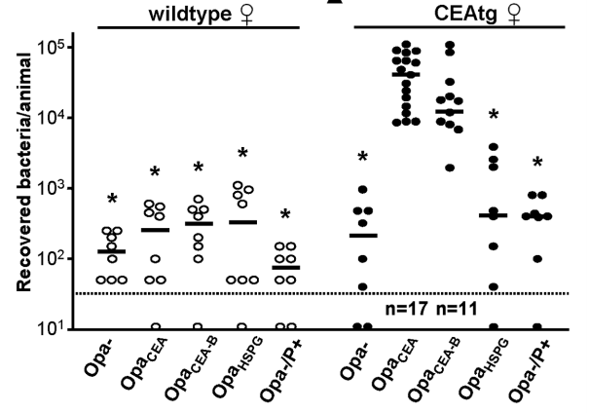

- The graph on the right is a measure of the number of exfoliating cells per unit of area after infection of either WT mice or CEA transgenic mice with no bacteria (uninfected), Opa_{CEA} or Opa_{HSPG} Ngo bacteria. After summarizing the results of this graph, explain in as much details as possible what is the effect of Opa_{CEA} binding to CEA is the context of this infection. (5 points)

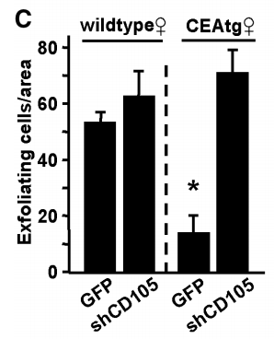
- One question arising for the previous data stems from the fact that CEA is expressed apically in epithelia and the effect seem to be on the attachment of cells. One candidate gene to potentially explain this conundrum is CD105, a basally expressed protein that is overexpressed upon interaction with bacteria on CEA expressing cells. Scientists performed similar experiments but with mice transduced with either on empty vector carrying just GFP or a vector carrying GFP and a small hairpin RNA targeting CD105 (shCD105). Interpret the graph on the right and explain whether CD105 is indeed the missing link and summarize your understanding of the all experiments by a small schematics showing the different molecular actors. (6 points)

Answer keys:

A. The two images presented are Scanning Electron Micrographs of genital epithelia from WT mice (1 point for stating what they are). In the non-infected image you can see a continuous epithelia barely distinguishing the different cells, whereas in the case of infection with Ngo the cells are exfoliating you can distinguish different cells coming of the main surface of the epithelium (1 point for the description of each condition). Those images show that upon infection with bacteria the genital epithelium responds by shedding cells surely a primary mechanism of the innate immune system to combat bacterial infection.

B. Wild type female mice infected with Ngo bacteria whether they carried Opa genes or not and independent of the ability of these Opa proteins to bind to CEA or HSGP had very little bacteria that could be recovered from the urogenital region a day post-infection (below a 1,000 bacteria on average per animal)(1 point). On the other hand transgenic CEAtg female mice bearing the human CEA gene infected with Ngo bacteria able to bind to the CEA gene through their Opa protein (Opa_{CEA} or Opa_{CEA-B}) had above 10,000 bacteria recovered per animal. Infection with bacteria not binding with CEA led to a result similar to the Wild Type, below 1,000 bacteria per animal. (2 points). The interaction between Opa_{CEA} and CEA is thus triggering signaling that prevents the clearing of the bacteria and leads to more bacteria being recovered from the animals bearing the CEA gene. (2 points)

C. The graph is a quantification of the amount of exfoliating cells per unit area of epithelium. The basal level of exfoliation (uninfected wild type mice) is around 20 cells per unit area (1 point). Upon infection by Ngo bacteria we now from A that cells are shed and this is quantified as a rise in number of exfoliating cells per unit area to three times the basal level at 60 cells per unit area (1 point). In the case of CEAtg mice infected with Ngo bacteria with Opa_{HSGP} that cannot interact with CEA the number of exfoliating cells per unit area is similar to the number seen in the case of infection of WT mice with around 50 exfoliating cells per unit area (1 point). But the striking result is that CEAtg infected with Opa_{CEA} Ngo cells are presented basal level of exfoliation with around 20 exfoliating cells per unit area (1 point). The interaction between CEA and Opa_{CEA} thus blocks exfoliation (1 point).

D. In the case of WT mice the transduction of a virus bearing either GFP or shCD105 that would reduce the level of CD105 in the cells has no effect on the number of cells exfoliating during infection (both around 60 exfoliating cells per unit area) (1 point). In the case of CEAtg mice, transduction of a control virus bearing GFP shows the same results seen in C where upon infection the genital epithelium shows basal level of exfoliation (1 point). But the real information is gathered when we see that transduction of a virus bearing shCD105 is showing high levels of exfoliation similar to cases where CEA and Opa_{CEA} interaction didn’t occur (1 point). So it seems that interaction between CEA and Opa_{CEA} will lead to an up regulation of CD105 that will in turn prevent exfoliation. (1 point)

Below are examples of potential schematics but anything that explains graphically what is happening will get 2 points.

